Name: Probin T Bhagchandani
ID: 22DCE006
Department: DEPSTAR Computer Engineering(CE-1)
Semester: III
Subject: IT283-WebDesigning & UI/UX
Assignment: FIGMA Assignment-3

1)Create a Cricket Website Home Page using FIGMA

Output:
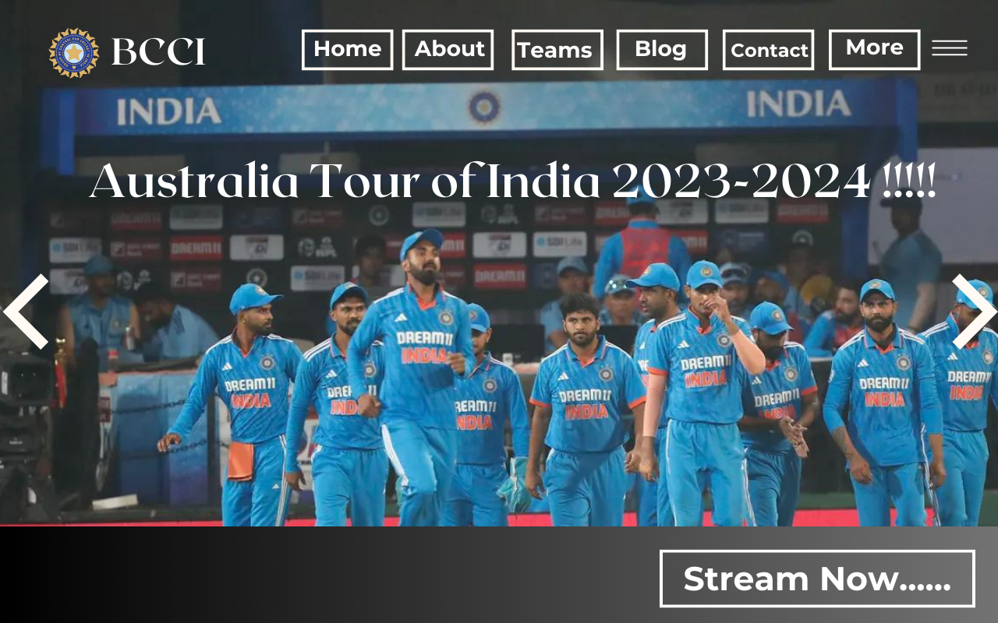

2)Create a Food page using FIGMA

Output:


